

Research Study Information Sheets

Study Title: Ambient and Passive Collection of

Sleep and Circadian Rhythm Data (AMBIENT-BD)

Thank you for your interest in our research study. Please read this information sheet carefully. Take your time to read it and don’t feel under any pressure to decide right away. It is important for you to understand the study fully before you decide to participate or not. If anything is unclear to you, or if you have any questions at all about the study, please don’t hesitate to get in touch with us by email (ambientBD@mu.ie (mailto:ambientBD@mu.ie)).

Ambient-BD is a research study that aims to investigate sleep and circadian rhythms. It is funded by the Wellcome Trust and will run from 2023-2028. Ambient-BD is a joint project between Maynooth University and the University of Edinburgh. You are invited to participate in the first part of the study that will be carried out at Maynooth University.

Why are we doing this research study?

Circadian rhythms are changes in physiology and behaviour that follow a 24-hour cycle. For example, the daily rhythm in body temperature, alertness and the sleep wake cycle are all examples of circadian rhythms. In fact, almost every cell in the human body is regulated by a circadian clock, and this does not depend on the light dark cycle or the timing of food or exercise. Circadian timing has been “hard-wired” into our physiology by evolution so that humans have 24-hour rhythms by default.

Deviation from this 24-hour rhythm is associated with detrimental effects on health and well being, and particularly for mental health. This might occur through irregular lifestyles, such as shiftwork, but many diseases are also associated with disturbed circadian rhythms especially neuropsychiatric conditions. People with bipolar disorder show signs of disrupted control of 24-hour rhythms such as problems with sleep timing and mood swings. The overall aim of Ambient-BD project is to investigate the reasons for this, but in order to do that, we need to validate methods that allow us to measure circadian rhythms.

The best method for measuring sleep is polysomnography (PSG), a test that monitors brain and heart activity and movement while people sleep. PSG can only be used to monitor sleep for 1-2 nights, and is not suitable for routine sleep assessment. The timing of sleep can be assessed by measuring increases in a brain hormone called melatonin that increases in the hours before bedtime. This test is called a “Dim Light Melatonin Onset

(DLMO)” test and involves measuring how quickly the melatonin levels in your saliva increase around bedtime.

In Ambient-BD we will develop and test new ways to measure rhythms using radar sensors, and compare them to PSG and DLMO.

Why am I being asked to take part in this research study?

We have asked you to take part because you are a healthy adult with no history of sleep disorder or neuropsychiatric disorders.

To participate you must:

Be at least 18 years old and less than 50 years old

Not have any sleep problems

Be healthy and not taking any drugs that could affect sleep

Live near Maynooth

Willing to have researchers visit your home

Be willing and able to consent to this study

Have access to email and the internet

You and anyone sharing your bedroom must be happy to have radar sensors fitted at the bedside

You can not participate if you:

Have current or previous diagnosis of a neuropsychiatric disorder (eg depression, schizophrenia, bipolar disorder)

Drink more than 11 (women) or 17 (men) alcoholic drinks per week

Have any chronic medical condition or disability

Take any prescription or over the counter medication that could affect sleep

Use any recreational drug

Are pregnant

Have obesity (BMI > 30)

Are a shiftworker

Have any infectious disease

Have allergies or skin condition that might affect your ability to have sensors attached to your skin, or to wear a wrist watch

Ever sleep with a pet or a child. Because of their small size it is difficult for the radar sensor to detect your sleep while they are there. It is possible to assess sleep if an adult sleeping partner is present Have any intention to travel across meridians (time difference more than 2 hours) during the 3-month study period. This is because “jetlag” disrupts your sleep.

Do I have to take part?

It is important to know that you do not have to take part in this study if you do not wish to. You can change your mind about participating in this study at any time, even after the study has begun. If you decide that you do not want to participate, this will have no effect on your or their current or future participation in any other research studies. You do not have to provide a reason for deciding not to participate or changing your mind. If you wish to opt out at any point, please contact the research team (Study email: ambientBD@mu.ie (mailto:ambientBD@mu.ie)), and we will organise this for you.

What happens if change my mind about participating during the study?

You can withdraw at any time and without giving a reason. If you decide to do so, we will immediately remove all of your data from the study, including your sensor, sleep and questionnaire data. Electronic copies of data will be overwritten, and hard copies will be destroyed by incineration. Biological samples will be destroyed by incineration.

How will the study be carried out?

The studies will be carried out as you undergo your usual activities over 3 months. A researcher will fit the sensors for PSG and to show you how to collect saliva samples and you will set up the bedroom sensor and wristwatch yourself. We will always give you instructions and all materials and equipment needed to complete the study and we will always be available to answer any questions you have about the study.

You will be asked to do the following tasks:

1. Wear a wrist-worn activity monitor (like a Fitbit) at all times (day and night) for 3 months. You will need to remove the monitor for showering or swimming, and put it back on as soon as possible afterwards. The device will monitor movement and light exposure continuously throughout the day and night.
2. Fit a bedside sensor that monitors movement and environment in your bedroom for 3 months (see image below). The sensor records the following information:

Movement

Room temperature

Sound in decibels

Light

This sensor uses radar to monitor movement and we can use this information to design algorithms that can guess whether you are awake or asleep. We cannot tell what you are doing when you are awake. It records noise levels, not sounds or voices and ambient light. This sensor transmits data via the internet to a cloud platform where we can download your data.

The sensor has its own internet connection and you will not be able to download the data or access the sensor controls. It is unobtrusive and makes no sound, and has no display. If you go on holiday or stay somewhere else overnight, we will ask you to bring their bedside sensor, if possible.

1. Complete some questionnaires about your health, lifestyle and sleep. The questionnaires will be completed at three time points during the 3-month study. Questionnaires will take approximately 10 minutes each to complete. You will need to keep a sleep diary for the 3 month study period.
2. Perform a melatonin test that will involve collecting saliva samples every 30 mins for 6 hours before bedtime and 2 hours after bedtime. This is called a “Dim Light Melatonin Onset (DLMO)” test and it measures how quickly the melatonin levels in your saliva increase at bedtime. You will need to do this once at the beginning and once at the end of the study. You will receive instructions from a trained researcher on how to collect these saliva samples and we will provide you with saliva collection kits. Melatonin is a hormone of darkness and light will supress it straightaway. For this reason, the test must be performed in dim light and we will help you to adjust the light levels in your home for that. During the test, you will be allowed to read using a booklight that we will provide, but screen use is prohibited.
3. Complete a Polysomnography Sleep Test for 2 nights at the beginning and end of the 3-month study. This will happen at the same time as the melatonin test. Researchers will visit your home each night and fit the following sensors:

A nasal cannula to monitor airflow

A control unit strapped to your chest

ECG sensors to monitor heart rate and rhythm

Straps to monitor chest and upper abdominal wall movement.

Oxygen saturation sensor worn on the finger

Skin sensors to monitor muscle tone in your chin, leg, chin and eye

You will need to sleep overnight wearing all of these sensors and then remove them yourself the following morning.

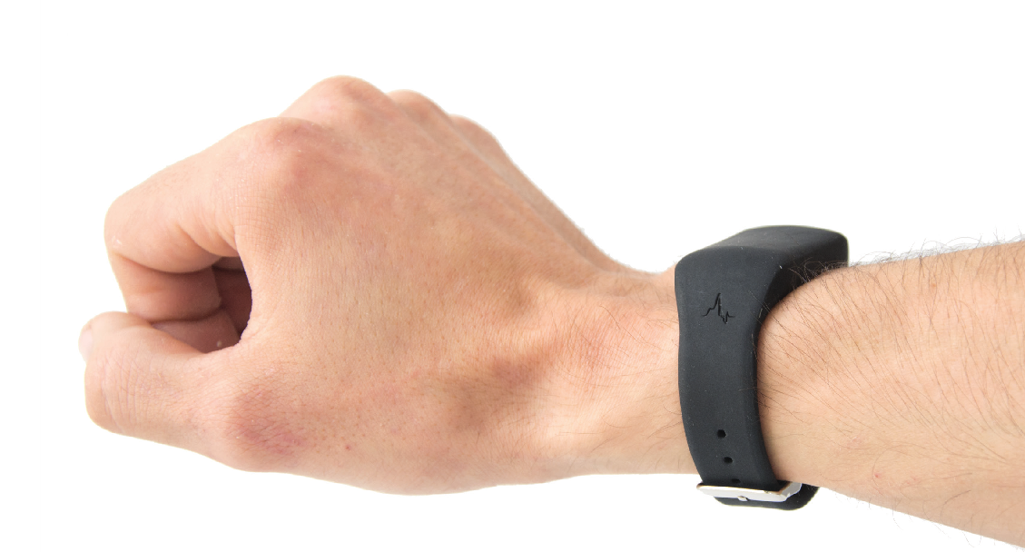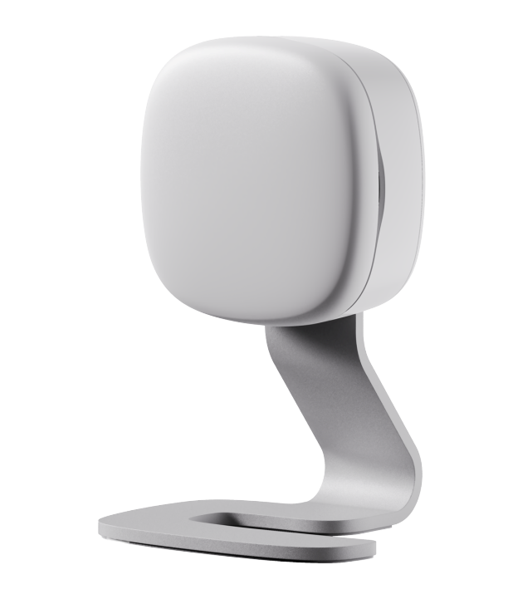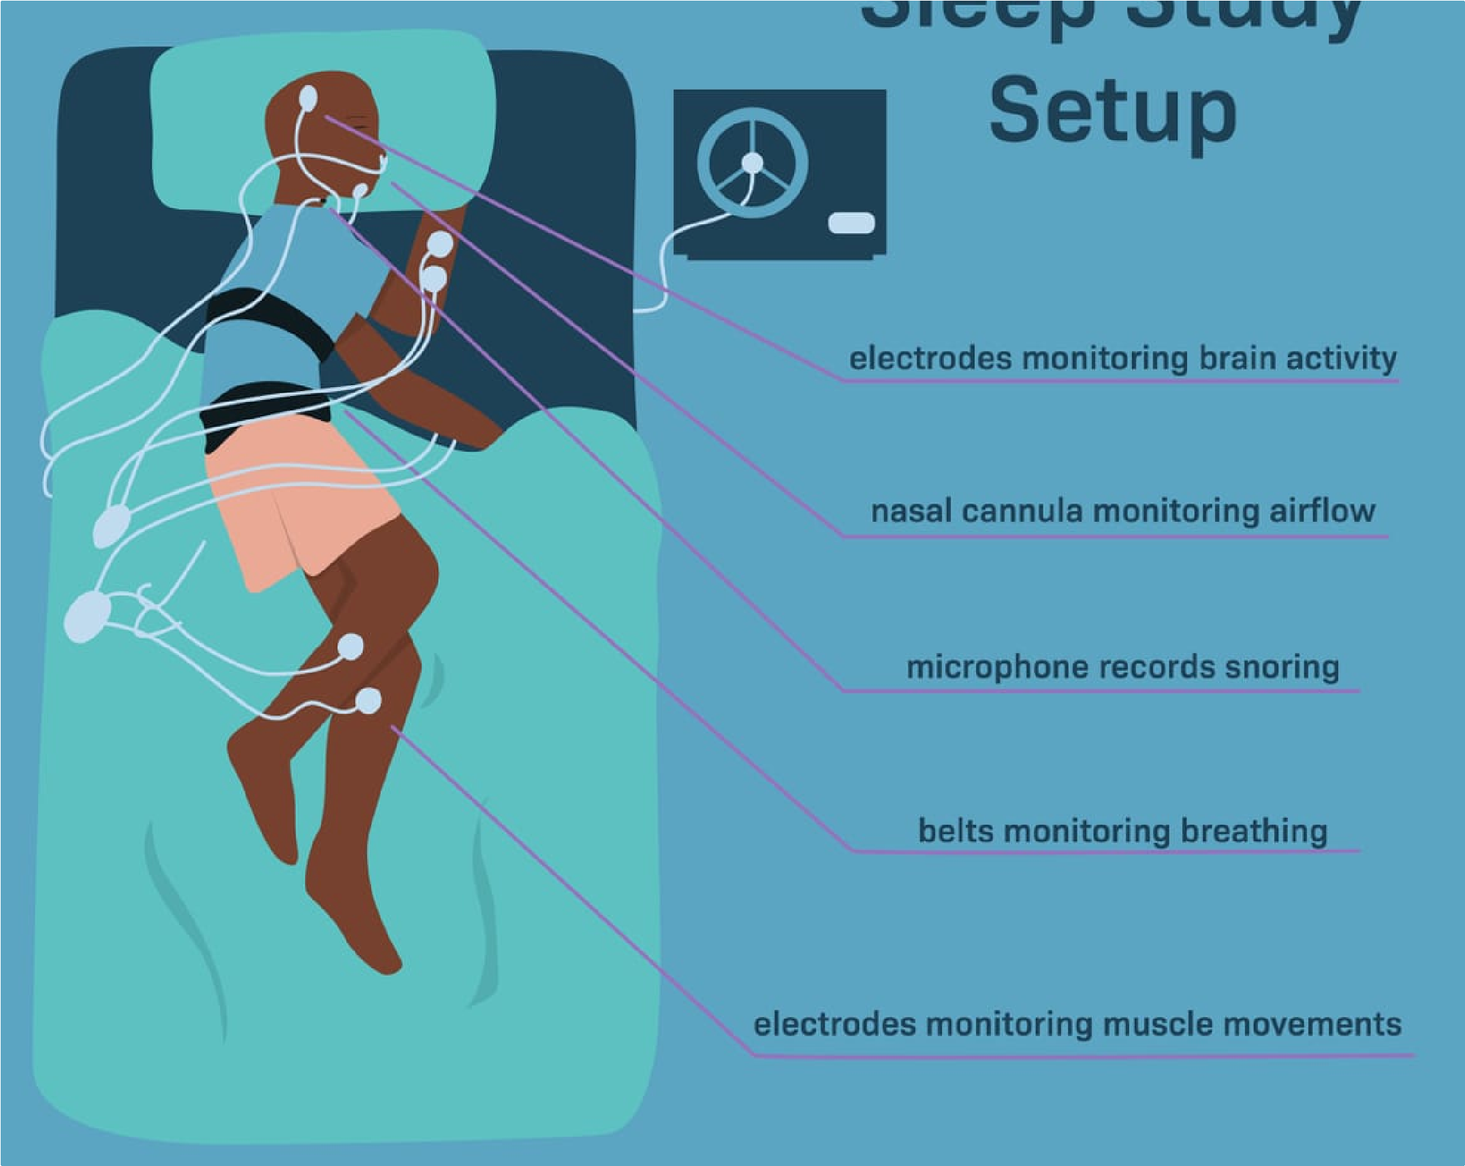

**Polysomnography Sensors**

electrodes monitoring brain activity

electrodes monitoring airflow

electrodes monitoring snoring

belts monitoring breathing

electrodes monitoring leg movement

**Wrist-Worn Sleep Sensor**

**Bedside**

**Sensor**

When will I need to do all these tasks if I agree to take part?

The tasks in this study will be arranged at times that suit you. There will need to be 3 months where you are able to wear the wrist strap and use the bedside sensor continuously. It is no problem to take this items to another location if you need to travel during this time. During the 3 months you will need to have 2 days in month 1 and 2 days in month 3 that you are free to do the PSG and DLMO tests in your home.

After you have read this information sheet, and if you decide that the study is something you would still be interested in, we will have a short conversation (in person, by phone, MS Teams or email) to ensure that you are eligible to participate. This conversation is confidential and the information you give us at this time will not be recorded. If you meet the inclusion criteria, we will then send you information on what is involved and give you time to read this and to ask questions. Next we will ask you to meet again (in person or online, your choice) to give written consent to participate. Next you will need to have a screening PSG session to make sure that your sleep patterns are healthy before you can continue participating. If that is clear, then we will enroll you into the study and arrange a 3-month study window that suits you to participate. All tests will be carried out in your home and you must be happy for the researchers to visit to set up the PSG sensors and show you how to perform the melatonin tests. The researchers will be male or female trained scientists, but they are not medical doctors and you will not be offered any medical advice at any point during this study. You will have the names and contact details of the researchers who you can contact at any time during the study, should you have any questions. You will need to complete questionnaires about your heath, lifestyle and sleep at the beginning, middle and end of the 3-month study. The diagram below summarises what you will need to do and when.

DMLO stands for Dim Light Melatonin Onset, this test will monitor the rate at which melatonin (a hormone that signals darkness) rises in your saliva as bedtime approaches. PSG stands for polysomnography, a test that monitors sleep by measuring brain and muscle activity.

To summarise, over the 3 months we will:

record questionnaire data at three timepoints continuously record daily movement data using the wrist worn sensors, and the bedside sensor measure melatonin evening increase in saliva on and measure sleep by PSG on two occasions during the 3-months

Can the sensors record images?

No, the sensors only measure movement in space, none of them can acquire images.

Can the sensors record what I am saying or other sounds?

No, the sensors record noise levels in decibels, they can’t identify sounds or record speech.

Can the sensors identify my location?

No, none of our sensor have GPS or capacity to identify or record their location.

Can the bedside radar sensors identify what I am doing?

The sensors record data on movement but it is not possible to identify what someone is doing other then whether they are awake or not. We apply algorithms to the movement data at each timepoint to classify whether the person is asleep or awake – it is a binary variable, either awake or asleep, nothing else. The data cannot be used to detect sexual or any other activity nor would we ever attempt to detect anything other than the binary classification of being awake (1) or asleep (0).

Can the bedside radar sensor record data from my partner?

The sensors will only record data from you and not your partner (as long as you are the person closest to the sensor). Your participation in this study does affect your partner as we will record light, sound and temperature data in their bedroom, and we ask you to make sure anyone sharing your bedroom is happy for you to participate.

Are there any benefits to me if I take part in the study?

Medical advances depend on the goodwill of volunteers that participate in research studies, and we believe that you will benefit from knowing you are making a valuable contribution to finding ways to help people with bipolar disorder. We are very grateful to everyone that participates in our research.

You will receive data from the radar sensors that show how your own sleep patterns and the environmental conditions in your bedroom vary over 3 months. This will benefit you by helping you to understand more about how you sleep over a long period of time. We will give you this data for your own interest at the end of the study, but we are not medical doctors and we won’t be able to help you understand it.

In recognition of the time and effort it will take you to perform the PSG and melatonin tests on two occasions, we will give you a gift voucher of 250 euros when you have completed both tests.

We will not return the results of your melatonin or PSG tests, as these are research data and it would be difficult to understand what they mean at an individual level.

What if I already have problems with my sleep?

Our research requires participants to have healthy sleep so if you already have a sleep problem you will not be able to participate.

What if you find any problems with my sleep?

Even if you think you have normal sleep and enrol in this study, there is a possibility that the tests we carry out identify that your sleep patterns are not what we expect to see in a healthy person. If this happens, we will let you know and we will give you copies of the data we collected. You will not be allowed to continue to participate in the study at this point. We are not medical doctors, so we will not be able to give you any advice but we will recommend that you discuss our findings with your GP. We will give you copies of your data that you can discuss with your GP.

Are there any risks to me or others if I take part in the study?

We have taken great care to identify and address any potential safety concerns, and we do not consider that taking part presents a risk to the participants but we do ask you to pay attention to the following sources of risk.

Remember if you are unsure about anything, please feel free to contact our research team at AmbientBD@mu.ie (mailto:AmbientBD@mu.ie) or 087 199 8589.

1. There is a small possibility that you might develop skin irritation from the wrist worn strap or from the paste and tape used to attach the sensors to your skin in the PSG study, and we will ask you to be vigilant to this, and to remove the strap immediately and withdraw from the study if signs of irritation are detected. All the items we use are medical-grade and we do not anticipate skin irritation to be a serious risk.
2. There is a chance that the cables and wires of the sensors could be a trip hazard and we ask you to take care when moving near them and to make sure that all ends are tucked away.
3. The DLMO test is performed in dim light and we ask that you are especially careful not to trip or fall at this time.

What identifiable information about me will be used as part of this study?

With your consent, when we enroll you in the study, we will record your name, address and contact details (email and phone number). We will use your contact details to contact you about the research study, and not for any other reason. This data that can identify is highly confidential and will be destroyed when you have completed the study or in December 2026, whichever comes first.

As soon as you have enrolled in the study, you will be assigned a unique study ID code - this is called deidentification. Any information we gather from that point (sensor data, melatonin data, and questionnaire data) will be associated with the ID code and not with your name or contact details. This is not only for electronically stored data. For example, physical copies of questionnaires, your saliva samples will be labelled with your unique study IDs and not your name. Only the authorised research team at Maynooth University will have access to the ‘key’ that links your name to your ID code, and this information will be stored on an encrypted file on a password protected computer at Maynooth University. Neither your name nor ID code will be used when reporting the results of this research for publication or presentation; your contribution will be entirely anonymous. In this way, even the researchers working directly with your data will not know which participant it comes from; this link can only be made by retrieving the key.

The only reason we have a key at all is so that we can contact you to collect sensors and follow up with results, and we will destroy the key and all your contact information as soon as possible. This will be when you have completed the study, and the contact information of all participants will be destroyed in December 2026.

What other data will be collected about me during the study?

There are three types of data in this study (i) personal, identifiable data, (ii) personal data, (iii) anonymised data.

The personal, identifiable information that we will collect are your name, address and contact details (phone number and email address). These data can be used to identify you and are highly confidential. They will never be written on any of your research data items such as questionnaires or samples or sensor results. They will be linked to your research data via your study ID number and kept in a locked office or secure network that is separate to the research data stores. This means that even the Ambient-BD researchers will not be able to tell the identify of the participants from the research data they are working on. We will delete your identifiable data as soon as the study is over.

The research data that we collect about you includes personal information such as data on sleep, sensor data, lifestyle and health, age and sex, but these data are not unique to you and cannot be used to identify you without access to the ID code key. These data are de-identified until the end of the study (or Dec 2026 whichever is first) at which point all identifiable data are deleted and all personal data are anonymised. The personal research data will be identified only by an ID number and will be stored in a secure location on the MU server. De-identified data will not be shared with anyone outside the research team.

Anonymised data means that all connections to your identity have been irretrievably destroyed and there is no way that anyone (not even the researchers) can ever find out that information came from you. We ask your consent to retain this anonymous information indefinitely and to share it with other researchers and via scientific repositories. Repositories are public databases that can be accessed by anyone and are very important for progressing science and preventing other scientists repeating work that has already been done. Releasing our research data into the public domain like this means that science will benefit for many years after our project has finished, and that the experiments do not have to be repeated.

Will any of my data be shared with anyone outside Maynooth University?

Some of your de-identified (not your identifiable information) personal information (date of birth, sex and sensor data) will be shared with three companies that we use to analyse data. The companies are (i) VitalThings (Norway), (ii) Onlinesurveys.ac.uk (UK) and (iii) Novolytix (Switzerland). Details of these companies and why we need to share data with them are given below. We emphasise that we will never share data that could identify you with anyone outside of the study team. None of these companies will be given your name, all of the data shared will be identified by a study ID number.

VitalThings supply the radar sensors that we use and they are responsible for the transmission of data from the sensors to a cloud based platform that they maintain, and where the data are stored until the researchers at Maynooth University can download it. This method of temporary data storage in the cloud is the most efficient way that we can acquire and store large amounts of sensor data. They require access to your age and sex in order to calculate your sleep information. These data are identified by a study ID and can never be used to infer your identity. They will be made completely anonymous by Maynooth University researchers once the data have been downloaded.

Onlinesurveys.ac.uk are a specialist company that deliver surveys for academic research online. They provide the platform that collects your questionnaire data. The surveys will be identified by a study ID number only and there is no way that onlinesurveys.ac.uk can know which participant any survey relates to.

Novolytix will analyse your saliva samples to measure melatonin. We will send them your samples labelled with your study ID number but they will not be given any other information. They will report the results to us and then they will delete all your data and destroy any remaining saliva sample.

A data processing agreement has been signed between Maynooth University and VitalThings, onlinesurveys.ac.uk and Novolytix that will ensure that they maintain high standards of data security and governance and that they are GDPR compliant.

These companies will never be given access to your name, address or contact information. Following completion of the study, they will delete your data. After the study we will delete all your identifiable details so that your data are completely anonymous. We will store these anonymised data indefinitely in Maynooth University and in data repositories so that they can be used in future research and/or for teaching purposes (for example, student projects).

To summarise exactly who your data will be shared with:

1. Your identifiable data (eg name, address) will not be shared with anyone outside the research team at Maynooth University
2. Your de-identified personal data will be shared with companies that help us to collect data - VitalThings, Novolytix and onlinesurveys.ac.uk
3. There will be no limit on sharing of your anonymised data at the end of the study – they are open access for use by anyone. This will never include any data that could possibly identify you.

What will happen to my saliva samples at the end of the study?

All saliva samples will be retained by Maynooth University indefinitely after anonymisation and may be shared with other researchers interested in addressing the hypothesis of Ambient-BD. They will not be made available for any other purpose. Unfortunately we cannot ask for your explicit contest to participate in future studies, since the samples will have been anonymised at this point. Instead we ask for your consent in advance for your samples to be used in future studies that address the importance of sleep and circadian rhythms. Future studies will only be allowed to analyse biochemicals and hormones in your saliva; we will never extract or analyse any genetic information from your samples. We are not able to tell you now what these studies will be, as they will involve the scientific techniques that will be available in the future. Remember that the samples will be anonymised and can’t be linked to you in any way.

What happens to my data and saliva samples if I decide to withdraw?

If you decide to withdraw from the study, then all data will be deleted and saliva samples will be destroyed; nothing will be retained for anonymisation in this case. You will be completely removed from the study. If you withdraw we will ensure that our third party processor, VitalThings deletes your de-identified data from the sensors, sex and date of birth data. If you complete the study, your data will be anonymised and it will not be possible to withdraw from the study after this point.

Will my personal data and/or sensor data be used in future studies?

The data we collect will be anonymised once the sensors, samples and questionnaires have been returned, so it will not be possible for anyone, including the research team to identify the participants from the datasets. With your consent, we will retain these anonymous datasets indefinitely. These datasets may be used in teaching or research.

Will I have access to the data generated by future studies?

No. Following completion of the study or withdrawal from the study, your identifiable personal information including your name, address and contact details will be destroyed. All other data (sensor, melatonin and questionnaire data) will then be anonymised (it will no longer be linked back to you), and it will not be possible for us or anyone to identify you. For this reason, we cannot return any of your results after anonymization and you will not be able to withdraw, request access, or to make any amendments after the data are anonymised. This anonymised data will be held in Maynooth University and made available in public repositories for indefinite open access.

Who will access my identifiable personal data as part of this study?

Only the authorised researchers named above, working in the research team at Maynooth University will have access to your identifiable personal data including your name, address, and contact details. All other data (sensor data, age, biological sex, clinical information, melatonin data and sleep data) are only identifiable by your unique study ID. We will never label your questionnaires, saliva samples or sensor data with your name or contact details. VitalThings, Novolytix and onlinesurveys.ac.uk cannot access your identifiable information. Only the research team at MU can ever find out your identify, and this is only for the purposes of contacting you about the study. As soon as the study is completed all your identifiable information will be destroyed and there is no way that you can ever be linked to study data again.

How will my privacy be protected?

Your personal information will be kept entirely confidential, and we will exercise our duties in handling your personal data as per the General Data Protection Regulation (GDPR). Protecting your privacy is extremely important to all the research team members at Maynooth University. Personal Identifiers, such as your name or email are never used to label your questionnaires, sensor data or saliva samples. All data will be stored on password protected files on a secure network in Maynooth University. No one outside of the research team in Maynooth University will have access to your name or contact information and all other data will be labelled with your unique study ID. Please note that even the members of the research team that are working on the study on a daily basis will not know from which participant the data came from. To find this out, they would need to access a controlled file that connects your study ID to your identity, and to do so would be a violation of the research undertaking agreement that they have signed with Maynooth University. You will be known only by your study ID number; we retain identifiable information only for the purposes of contacting you during the study period.

Although all measures will be taken to protect your privacy, there is a remote risk that a connection to your contact details could be made, e.g., through unauthorised access to servers or premises at Maynooth University. To minimise this risk, any files containing these data are password protected and have restricted access, or are in locked cabinets in locked offices. Any attempt to identify you in this manner would be a legal breach against the permitted use of the research data.

When you have returned the sensors, questionnaires, and samples, and the study is complete, your contact details will be incinerated in the case of written records, and electronic data will be reformatted or overwritten by the research team at Maynooth University and all data will be anonymous.

What is the lawful basis to use my personal data?

As part of the study your personal data will only be used for scientific research which is in the public interests (Article 6 (e) and Article 9( 2) (j) of General Data Protection Regulation (GDPR)).

What are my rights?

Under the GDPR, you are entitled to:

The right to access to your data and receive a copy of it

The right to restrict or object to processing of your data

The right to object to any further processing of the information we hold about you (except where it is deidentified)

The right to have inaccurate information about you corrected or deleted

The right to receive your data in a portable format and to have it transferred to another data controller The right to request deletion of your data.

These rights to access to your data are forfeit in this study by the complete anonymisation of the data. Complete anonymisation is to protect the privacy and data security of the participants, but it also means that it is impossible for you to access your data for any reason. We will not record the identity of the participants that provided any specific item of data, so we will not be able to give you access to your data or to make any amendments.

It must be recognized that, in some circumstances, confidentiality of research data and records may be overridden by courts in the event of litigation or in the course of investigation by lawful authority. In such circumstances the University will take all reasonable steps within law to ensure that confidentiality is maintained to the greatest possible extent.

Will it cost me anything if I agree to take part?

Other than the cost of your time, there are no costs to you personally by participating in this research study.

Who is funding the study?

This project is funded by the Wellcome Trust (www.wellcome.ac.uk; grant number 226944/Z/23/Z)

What happens if I wish to make a complaint?

If you have concerns or questions about any aspect of the study or if you wish to make a complaint, please speak to the researcher you are working with or contact the research team (AmbientBD@mu.ie

(mailto:AmbientBD@mu.ie)) who will do their best to assist you. If they are unable to answer your question, please contact the Secretary of the Maynooth University Ethics Committee at research.ethics@mu.ie

(mailto:research.ethics@mu.ie) or +353 (0)1 708 6019. Please be assured that your concerns will be dealt with in a sensitive manner.

Will I be contacted again?

We will not contact you again after all data, equipment and sensors have been returned at which point we will destroy your name, address and contact details.

Who has approved this study?

This study has been reviewed and received ethical approval from the Biomedical and Life Sciences Research Ethics Sub-Committee (BSRESC) of Maynooth University on XXXXX. If you would like more information about the ethics committee’s approval of this study, please contact research.ethics@mu.ie (mailto:research.ethics@mu.ie).

Where can I get further information?

You can get further information from our research team

Ambient-BD Research Team,

Department of Biology,

Maynooth University, Co. Kildare

ambientBD@mu.ie (mailto:ambientBD@mu.ie)

The data processors for this study are the Ambient-BD Research Team in Maynooth University.

The Data Controller for this research project is Maynooth University, Maynooth, Co. Kildare.

Maynooth University Data Protection officer can be contacted at 17 Rye Hall Extension, Maynooth University, Co.Kildare

Maynooth University Data Privacy policies can be found at [https://www.maynoothuniversity.ie/data-protection (https://www.maynoothuniversity.ie/data-protection)](https://www.maynoothuniversity.ie/data-protection).